



AN ISO 9001:2015 CERTIFIED COMPANY



*Long Term Sustainability Through*

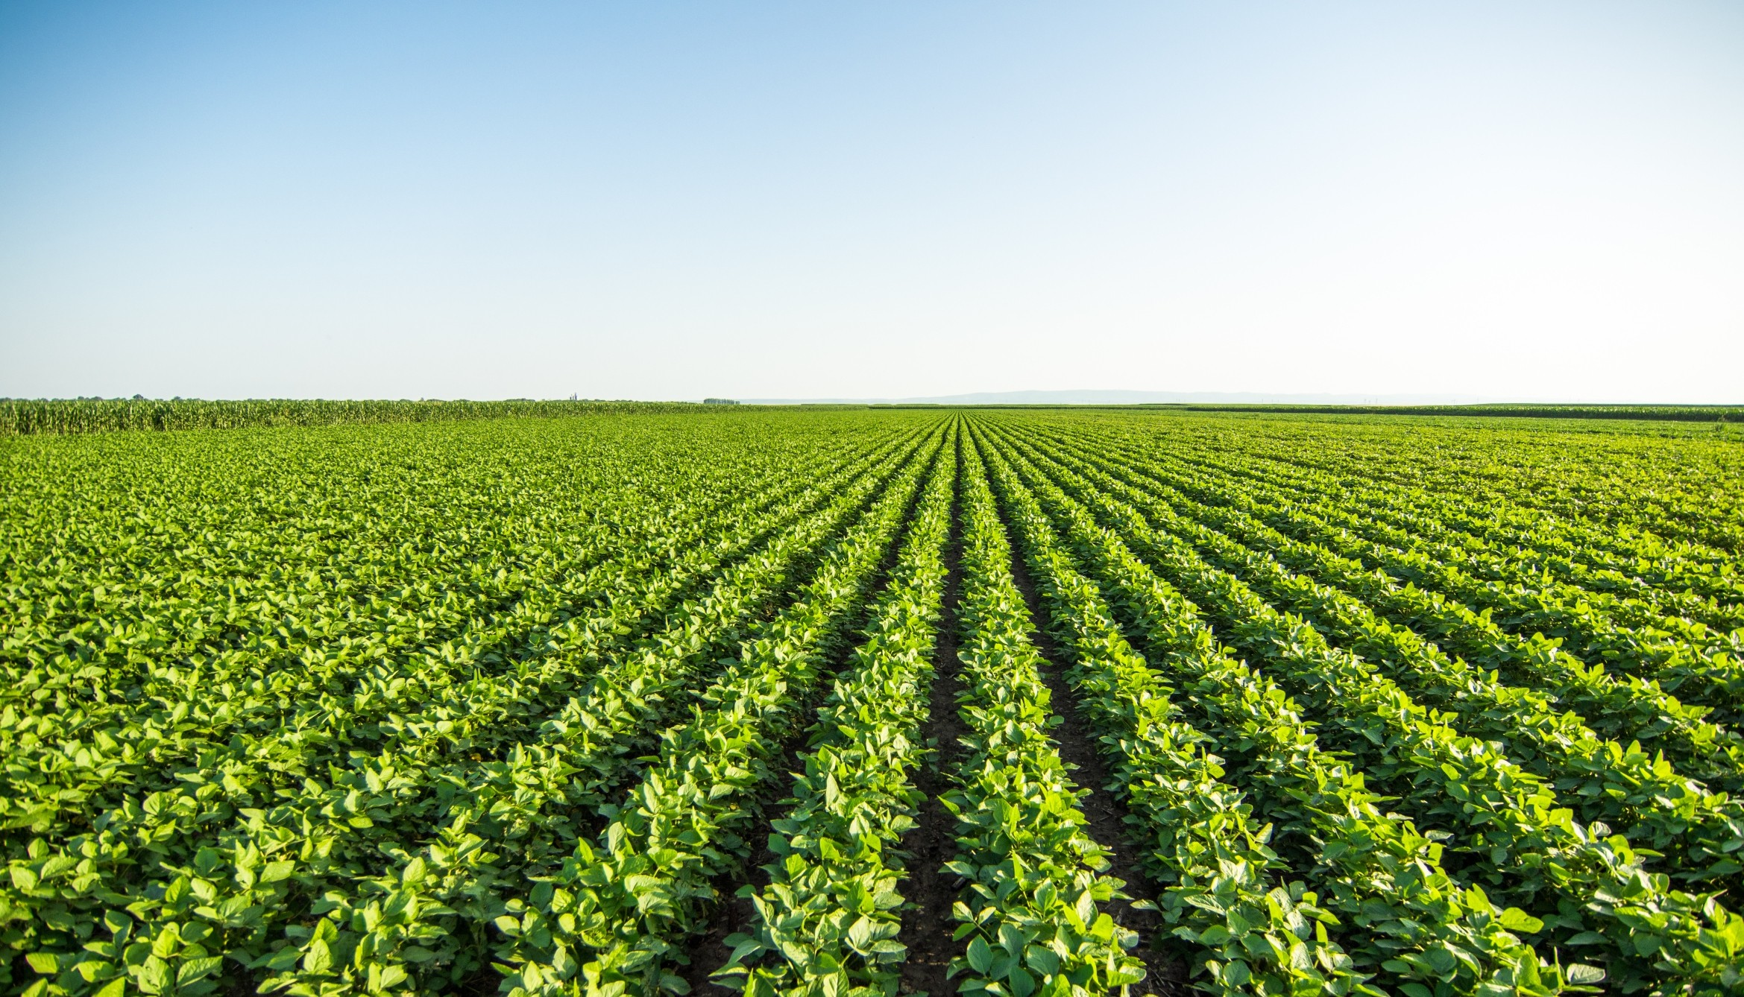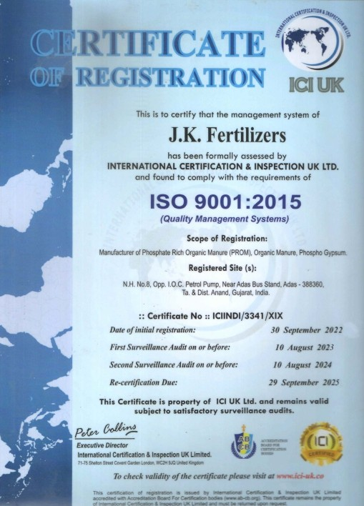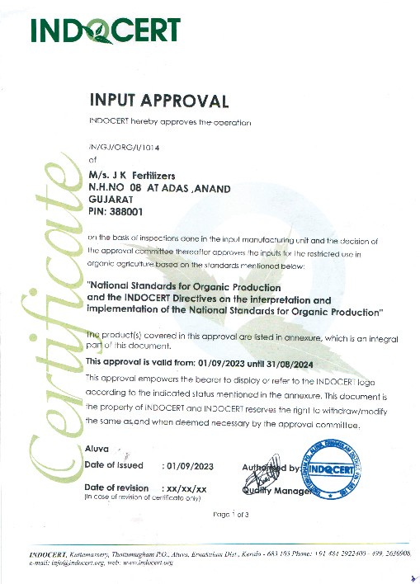

*We are certiﬁed with ISO 9001:2015 for Quality Management System & also certiﬁed with ISO 14001:2015 for Environment Management System.*

## Growth

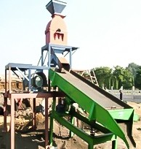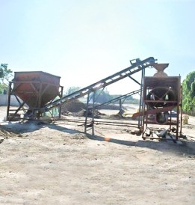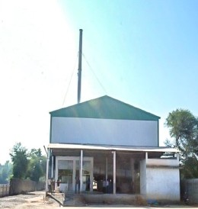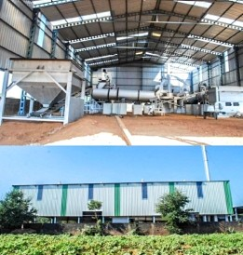

For “J K Fertilizers” growth is the only constant and a part of our DNA. Our Potential to growth is only limited by our ability to tap into the available of opportunities. We focus on business opportunities with a view to creating volume and cost eﬃciencies in our Operations. Our business has growth signiﬁcantly in last 15 years and we continue to invest to build a scalable business.

|  |  |
| --- | --- |
| **2016** | |
|  |  |

**2006**

**2008**

**2010**

**2012**

|  |  |
| --- | --- |
| **2014** | |
|  |  |



|  |  |
| --- | --- |
| **2018** | |
|  |  |

|  |  |
| --- | --- |
| **2020** | |
|  |  |

|  |  |  |  |
| --- | --- | --- | --- |
| **2022** | | | |
|  |  |  |  |

*Our key of success śs Tśme, Qualśty and Servśce.*

## Production Capacity

Granules

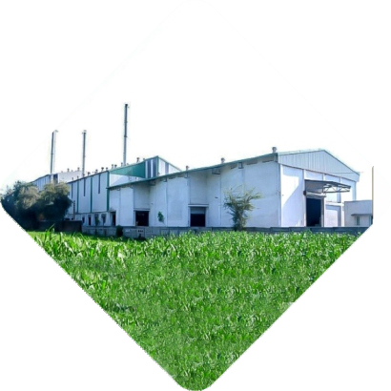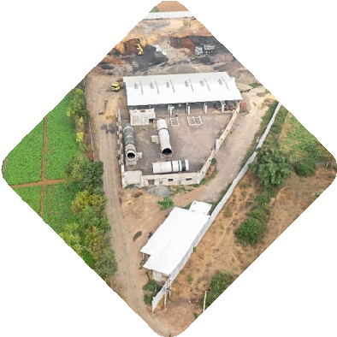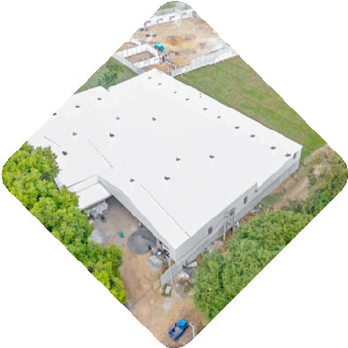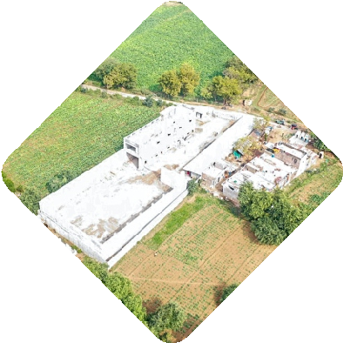

Powder

Coating Granules

Coating

Liquid

## Units in map

**UNIT-5**

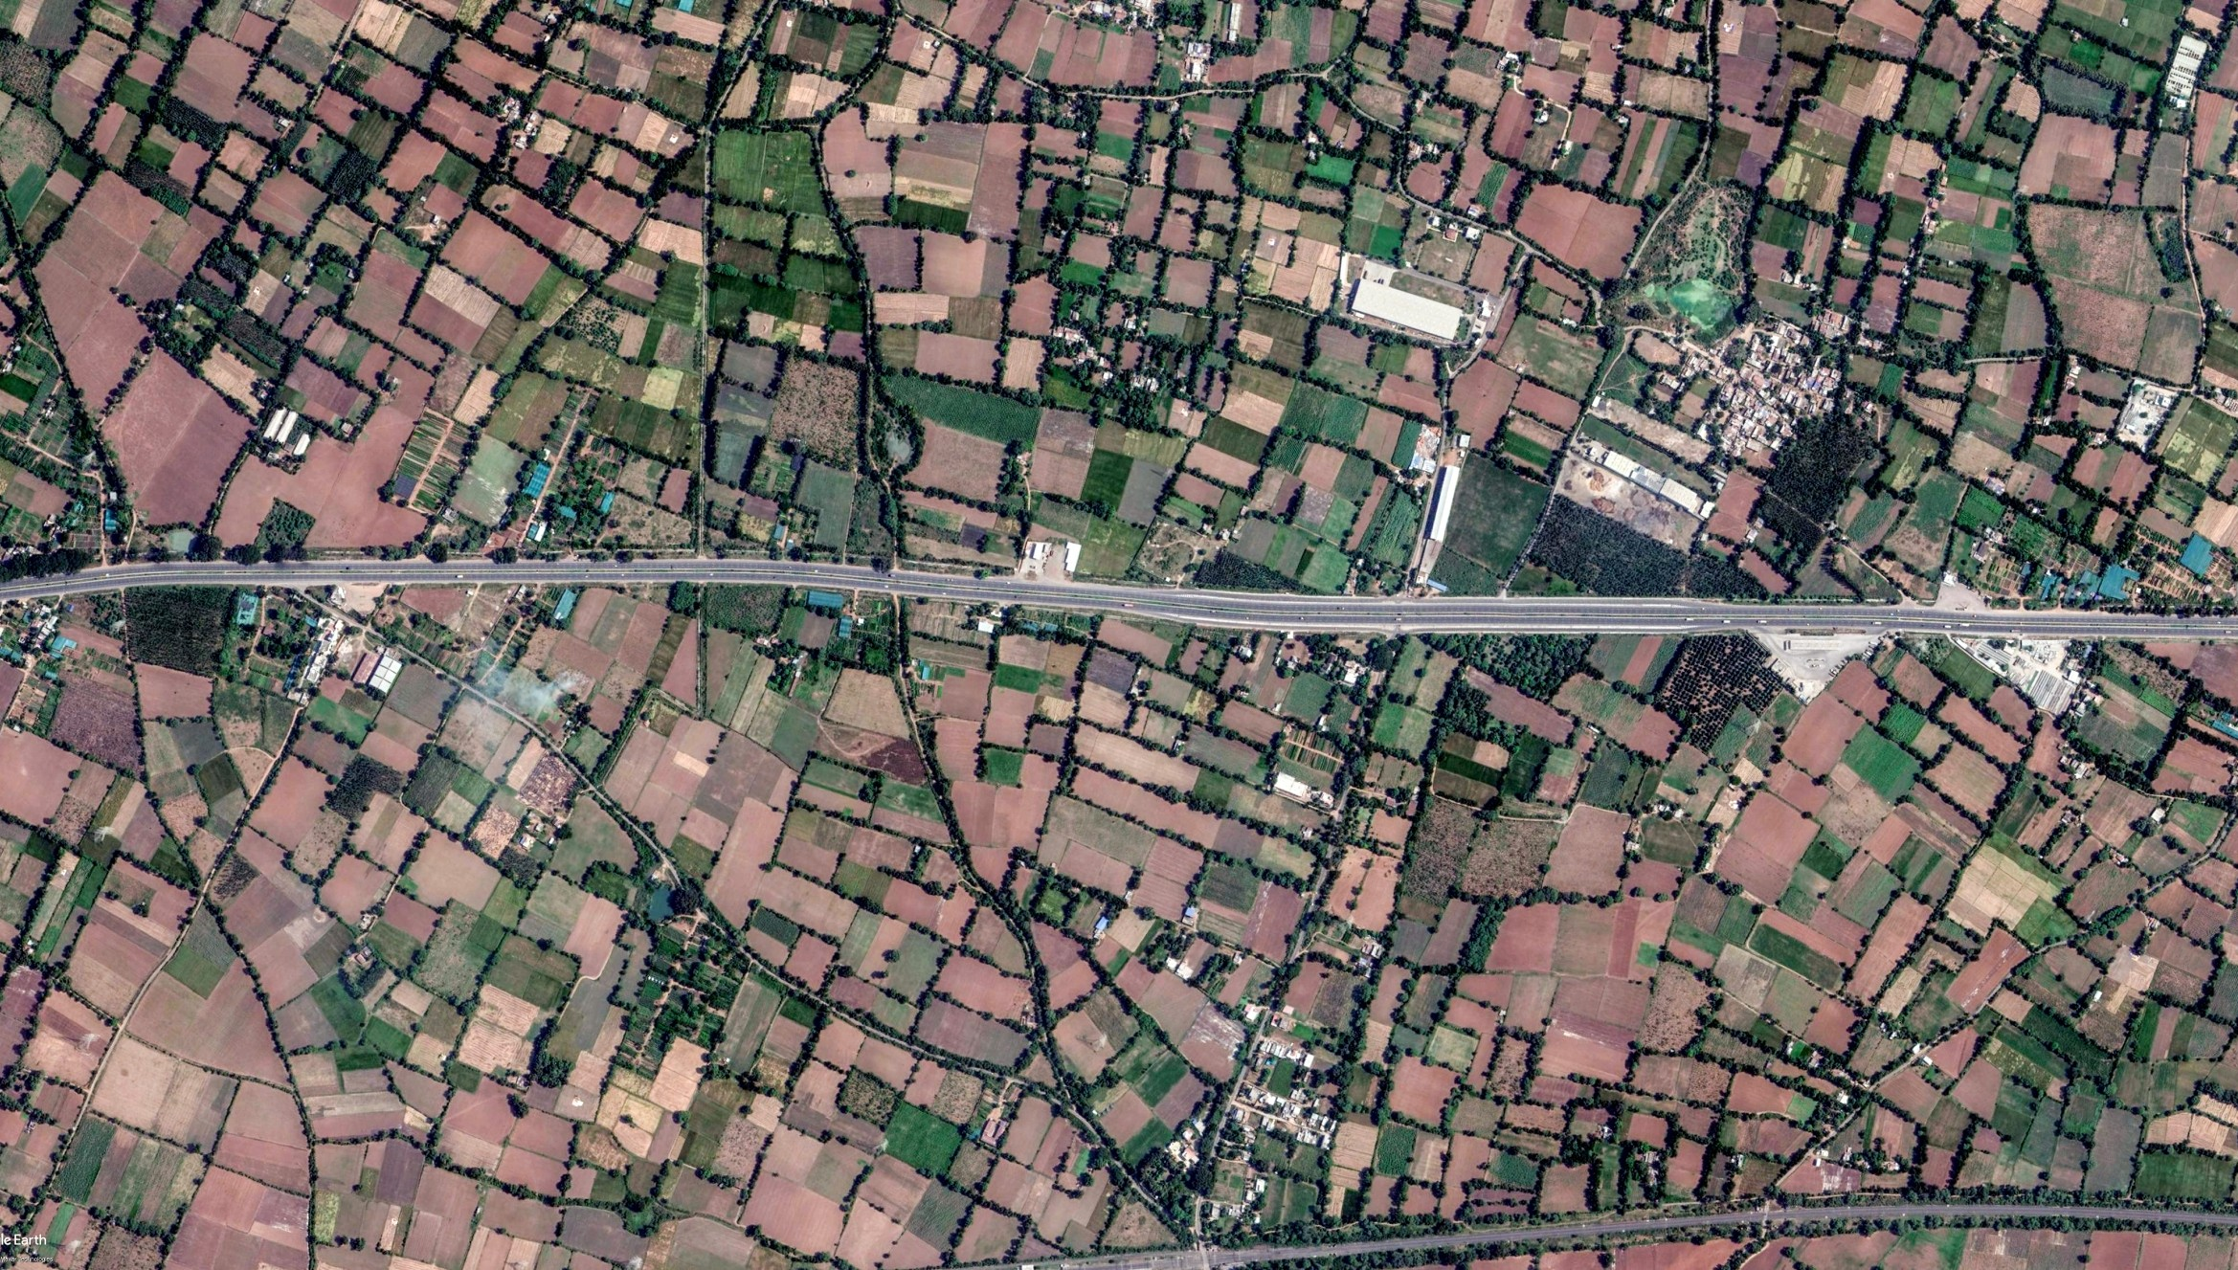

**UNIT-3**

**CR-1**

**UNIT-4**

**RM-1**

**UNIT-1**

**ADIT Farm**

**PM-1**

**N.H. NO. 48**

**N.H. NO. 48**

**Tridev Cement Article**

**RM-2**

**UNIT-2**

**RM-4**

**RM-3**

Unit-1 : Granulation plants - 100 + 200 mt./day

Unit-2 : Powder - 200 + 200 mt./day, 400 mt granulation plant Unit-3 : Granule Coating Plant - 30 + 60 + 100 mt./day

Unit-4 : Liquid Plant under construction Unit-5 : Coating Granule Plant - 50 mt./day

CR-1 : Customer required for exclusive area PM-1 : Packing Material Area

RM-1 : Raw Material Area -1 RM-2 : Raw Material Area -2 RM-3 : Raw Material Area-3 RM-4 : Raw Material Area-4

## Why J K Fertilizers

 Get Organic Powder Plant with capacity of total 400 MT./ day, Granules Plant with capacity of total 700 MT. /day, Granules Coating plant with total 190 MT. /day, Coating Granule Capacity 50

mt./ day and Liquid Plant with 15,000 Liter/day under construction.

 Testing laboratory facility with highly precision instruments.  Quality assurance for each product.

 State of art Equipment’s and Production Machinery.  Proper infrastructure to store raw material.

 Provide seperate ofﬁce and accommodation for your staff.  Separate premises for trucks parking.

 Skilled & Trained Manpower

 Timely production of products and Customer satisfaction  Customized production facility

 Sophisticated storage for ﬁnished Goods  Supervision through the process

 More than Decade year of Experience in Manufacturing Work for 24x7 in monsoon also.  Situated at middle in Gujarat.

Feel free to contact us for the best range of organic products and organic fertilizers.

## Product Range

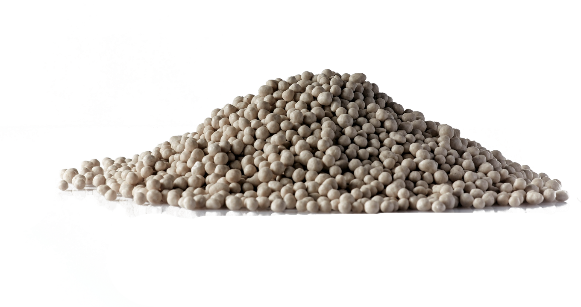



Organic Fertilizers







Product Range



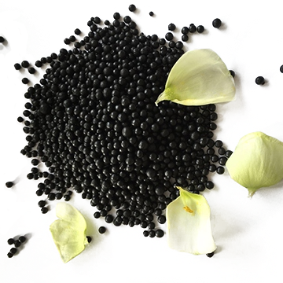Coated Fertilizers





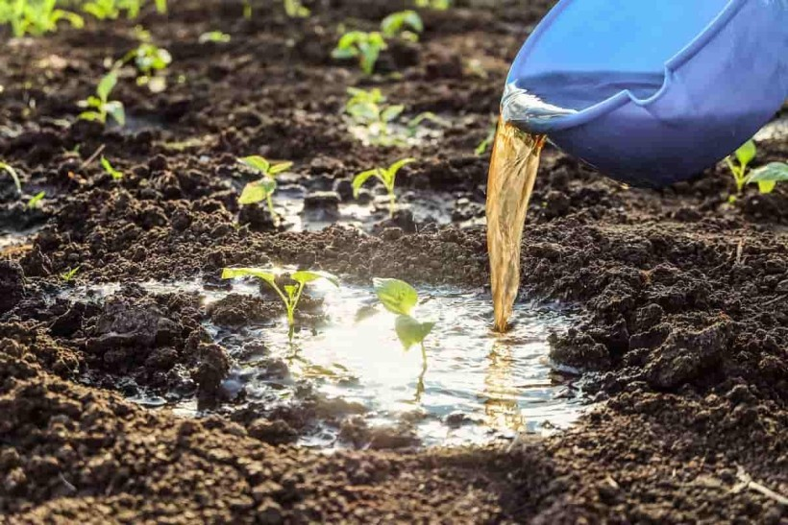

Liquid Fertilizers

## Advantages of Our Association

**ECONOMIC PRICING**

Quick Delivery of the best product at the right prices.

**CUSTOMIZATION**

Ready to customization product as per customers requirement.

**WITH YOU ALWAYS**

Being there when you need us the most.

**INNOVATIVE PRODUCT**

Bringing to you latest in new products.

**WORRYING TOGETHER**

Your sucess is our success.

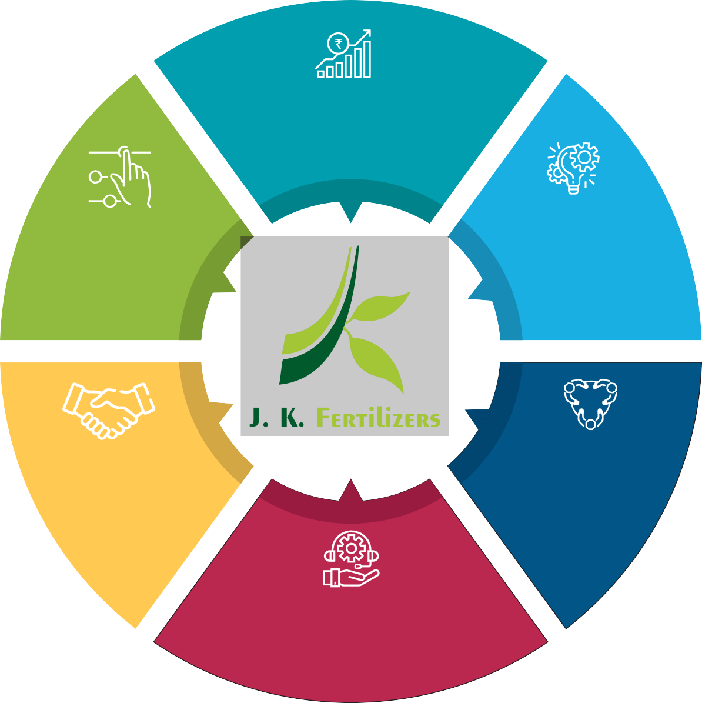

**TECHNICAL SUPPORT**

Giving you the best professional technical support.

## Vision & Mission

Vision



Increasing productivity and inviting gigantic players in the market for joint ventures with the apparition of providing their desired quality product. Adapting latest and Innovative Technology and providing our product to customers and big companies as per their desire.

## Mission



Providing better quality at reasonable price and collaborating with big players for enormous job works with an assurance to give the best with our on hand assets. Being responsible towards environment and society.

SWOT Analysis

# STRENGTHS WEAKNESSES



Huge Production Capacity Skilled Staff Infrastructure

R & D

Ability to Customize products.

Does not suits for drip irrigation Current technology can become obsolete in future.

Job Works

Joint Ventures for giving customer desired product Exploring export opportunity

Bad weather condition

Govt. policies for the product

# OPPORTUNITIES THREATS



Anand-Vadodara Highway, N.H. No.48, Adas Bus Stand, At. Adas (Vasad), Ta. & Dist. Anand (Guj.)

[sales@jkfertilizers.com](mailto:sales@jkfertilizers.com) [www.jkfertilizers.com](http://www.jkfertilizers.com/)

+91- 98250 45894

+91- 98250 45892